FIMRC  Interest MeetingS  When/WHERE  **Insert dates and locations of meetings**  Come learn more about our organization! |  |  | 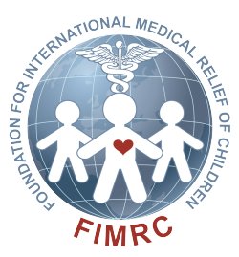  Who We Are:  Foundation For International Medical Relief of Children  What We Do:  We volunteer in the local community, fundraise to support clinics overseas, and go to a project site every Spring Break!  ALL STUDENTS ARE WELCOME!

